Fingertip Pulse Oximeter
User’s Manual
Ver: 1.0
General description
The Fingertip pulse oximeter, based on all digital technology, is intended for noninvasive spot-check measurement of functional oxygen saturation of arterial hemoglobin (SpO2). Advanced DSP algorithm can reduce the influence of motion and improve the measurement accuracy during low perfusion.
Technical Parameters
Display Method: Color OLED display, 2 display directions.
Power Requirements: Two AAA size 1.5V Alkaline Bаttеrу
Power Consumption: 30mA (Normal)
Measurement Performance in Low perfusion Condition: 0.3%

SpO2 Parameter
Measuring range | 35% - 100%（resolution 1%）
Accuracy | 70% - 100% : ±2%; 0 ~69%: unspecified
Pulse parameter
Measuring range |  |  | 30bpm – 250bpm(resolution:1bpm)
Accuracy |  |  | ±2bpm or ±2% adopt max
Safe mode |  |  | Inner power device，BF type application part.
Pulse strength
Range |  |  | Continuous Pulse bar display. The higher, the stronger
Dimension and weight
Dimension |  | 60（L）×36（W）×31（H）mm
Weight |  | About 50g(including batteries)

Product Properties
Operation of the product is simple and convenient.
The product is small in size, light in weight (total weight is about 50g including batteries) and convenient to carry.
Power consumption of the product is low, and two AAA batteries can be used continuously for 24 hours normally.
Battery voltage will be indicated in visual window when the voltage is so low that normal operation of the Oximeter might be influenced.
The product will automatically be powered off when no finger is in the device for longer than 16 seconds.
Product Operation Scope
The fingertip Oximeter can be used to measure human Hemoglobin Saturation and heart rate through finger. The product is suitable for use in home based situations.

The product is not suitable for continuous monitoring.
Operating Instructions
Press the function button on the front panel to turn on the oximeter.
Squeeze the end of the unit opposite from the function button to open the oximeter. Insert one finger into the opening of the Oximeter, fingernail side up. Release the clamp. Stay still and follow the instructions on the device. Results will be spoken when measurement is done. Results will also display on the screen.
To change the display direction, while the finger is out, press the function button again. This rotates the print display.
Long press the function button to enter the Settings screen.
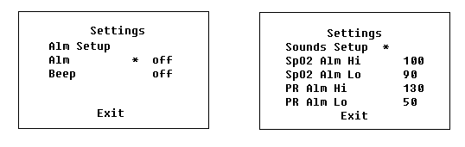
Short press to switch among the settings, long press to change the current settings of sounds and alarm limits.

After turning on the oximeter, each time you press the function button, the oximeter will switch to another display mode, there are 4 display modes totally.
When your finger is inserted into the Oximeter, your nail surface must face upward.
Results may be wrong if finger is not completely inserted.

Declaration: Please use rubbing alcohol to clean the rubber touching the finger inside the Oximeter, and clean the test finger using alcohol before and after each test. (The rubber inside the Oximeter belongs to medical rubber and has no toxins or products harmful to skin.)
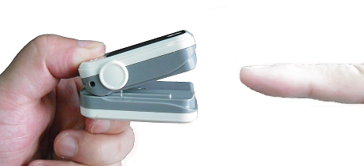
Brief Description of Front Panel
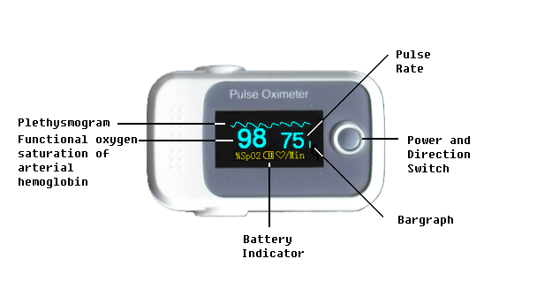
The length of Bargraph indicates the intensity of the pulse.
Product Accessories
One lanyard
Instruction manual
Battery Installation
Put the two AAA batteries into battery cassette in correct polarities.
Close the battery cover.
Note: Battery polarities must be correctly installed. Otherwise, damage might be caused to the machine.
Please remove the batteries if the Oximeter will not be used for long time.

Lanyard Installation
Thread thinner end of the lanyard through the hanging hole.
Thread thicker end of the lace through the threaded end before pulling it tightly.

Maintenance and Storage
Replace the batteries when the battery indicator is low.
Clean surface of thе fingertip Oximeter before use.
Remove the batteries inside the battery cassette if the Oximeter will not be operated for a long time.
It is best to preserve the product in a place where ambient temperature is -10-50℃ and humidity is 10%-95%.
Avoid exposure or direct sunlight.
Avoid excessive radioactive infrared rays or ultraviolet rays.
It is recommended that the product should be kept in a dry environment anytime. A wet ambient might affect its lifetime and even might damage the product.
Please follow the law of the local government to deal with used battery.

Outline dimension
Length: 60mm
Width: 36mm
Height: 31mm
Weight: 50g (including two AAA batteries)

Environment requirements
Operation Temperature: 5-40℃
Storage Temperature: -10-50 ℃
Ambient Humidity: 15%-80% in operation
10%-95% in storage

Troubleshooting
There are no user-serviceable parts inside the oximeter. The cover should only be removed by qualified service personnel.
If you are uncertain about the accuracy of any measurement, check the patient’s vital signs by alternate means; then make sure the oximeter is functioning correctly.
Do not spray, pour, or spill any liquid on the oximeter, its accessories, connectors, switches, or openings in the enclosure as this may damage the oximeter.

Problems | Possible Reason | Resolutions
Oxyhemoglobin or heart rate can not be shown normally | 1. Finger is not plugged correctly.  2. Patient’s perfusion is too low to be measured. | 1. Retry by plugging the finger  2. Try some more times, If you can make sure about no problem existing in the product, Please go to a hospital timely for exact diagnosis
Oxyhemoglobin of heart rate is shown unstably | 1. Finger might not be plugged deep enough.  2. Finger is trembling or patient's body Is in movement status. | 1.Retry by plugging the finger  2.Try not to move
The Oximeter can not be powered on | 1. Power of batteries might be inadequate or not be there at all. 2.Batteries might be installed incorrectly.  3.The Oximeter might be damaged. | 1. Please replace batteries  2. Please reinstall the batteries  3. Please contact with local customer service center
The screen are suddenly off | 1. The product is automatically powered off when no signal is detected longer than 16 seconds.  2. Power quantity of the batteries is exhausted. | 1. Normal  2. Replace the batteries
Symbols Definitions

Symbol | Definition
 | Type BF equipment (Refer to IEC 60601-1:1995)
 | Attention! Please refer to this manual.
%SpO2 | Oxygen saturation of arterial blood
/Min | Pulse rate
 | Symbol for the marking of electrical and electronics devices accordin to Directive 200296/EC.  The device, accessories and the packaging have to be disposed of waste correctly at the end of the usage. Please follow Local Ordinances or Regulations for disposal.  Note: The Oximeter is appied to this regulation.

